**Question 2: Create a balance table about the colleges.**

| Balance Table Comparing Ranked and Unranked Schools | | | | | | |
| --- | --- | --- | --- | --- | --- | --- |
|  | **Unranked School Adj. Mean** | **Unranked School Adj. SD** | **Ranked School Adj. Mean** | **Ranked School Adj. SD** | **Mean Difference Adj.** | **Mean Threshold (.1)** |
| Academic Quality | 0.52 | 0.31 | 0.47 | 0.28 | -0.19 | Not Balanced, >0.1 |
| Athletic Quality | 0.56 | 0.26 | 0.55 | 0.28 | -0.02 | Balanced, <0.1 |
| Near a Big Market | 0.69 | NA | 0.70 | NA | 0.01 | Balanced, <0.1 |

**Notes:** The balance table output indicates that academic quality is unbalanced between ranked and unranked schools. Academic quality is the only covariate where the standard mean difference is above the 0.1 threshold for balance (source: https://cran.r-project.org/web/packages/MatchIt/vignettes/assessing-balance.html). The mean differences are standardized using the col_w_smd() function, which computes the weighted mean differences for binary treatment. Given this information, the balance table failed.

**Question 3: Comment on the following issue. As you know, propensity score methods are more credible when we (the researchers) are able to use all variables that the agents who assign treatment scan use in their assignments. Comment on how this applied to this setting.**

There may be unobservables that go into whether a school is ranked (treated) or not that we do not have access to in our dataset. For example, variables like school size, how much budget is allocated to sports, etc. could play a role in whether a given school is ranked. On paper, we may have very good matches, but perhaps we have an *Ozzy Osbourne & Prince Charles* phenomenon: there are great matches, based on the observables the researchers have access to, but in actuality the matches may be very different.

**Question 4: Develop a simple model of who is ranked. Feel free to use linear or logistic regression. Output the coefficients of this model, so that you can show which factors predict (and which don't).**

|  |
| --- |
| **Simple Model of Who is Ranked in 2017** |
|  |
|  | Dependent variable: |
|  |  |
|  | Ranked in 2017 |
|  |  |
| Academic Quality | -0.884 |
|  | (0.780) |
|  |  |
| Athletic Quality | 1.964** |
|  | (0.806) |
|  |  |
| Near a Big Market (1) | 1.615*** |
|  | (0.459) |
|  |  |
| Constant | -1.378** |
|  | (0.645) |
|  |  |
|  |  |
| Observations | 100 |
| Log Likelihood | -59.554 |
| Akaike Inf. Crit. | 127.107 |
|  |  |
| Note: | *p<0.1; **p<0.05; ***p<0.01 |

**Notes:** The logistic regression table output indicates that athletic quality and near big markets are significant predictors of whether a school is ranked or not.

**Question 5: Use stacked histograms to show overlap in the between ranked and unranked schools.**

**Plot 1:**

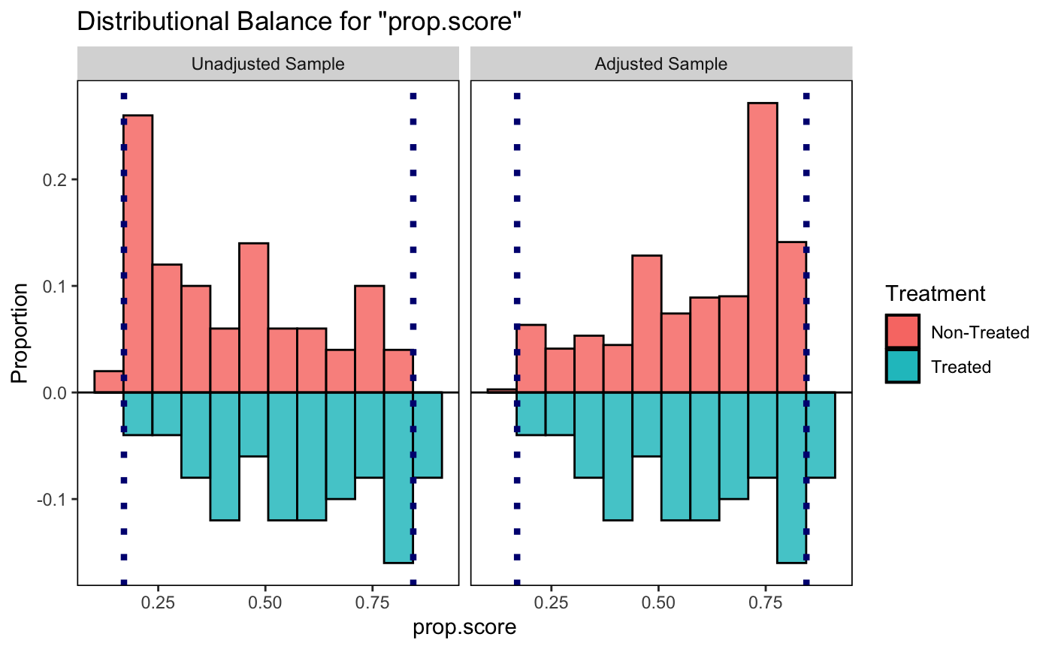

**Plot 2:**

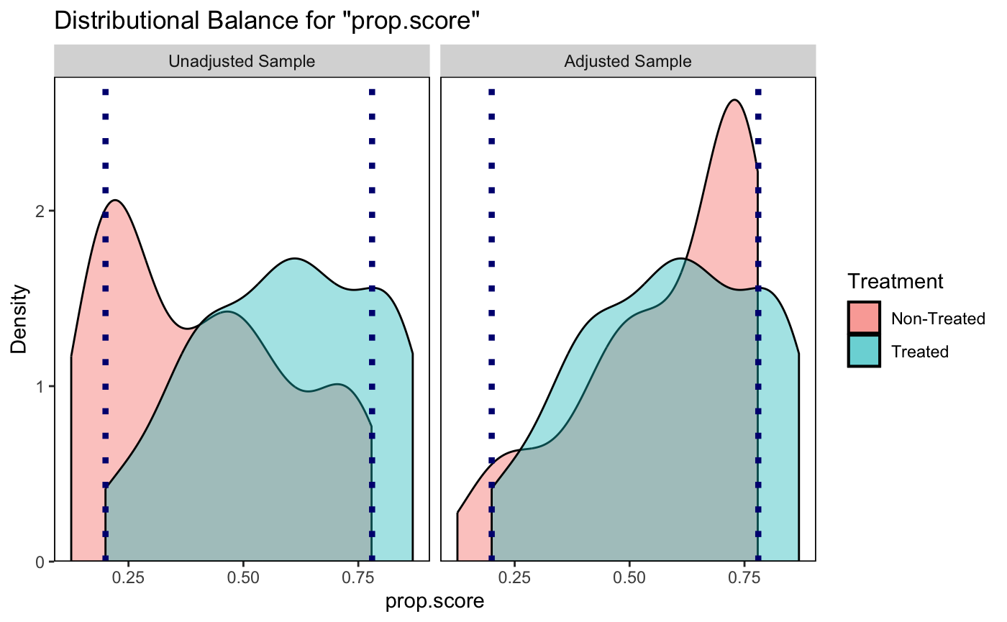

**Notes:** Both plots show (in slightly different ways) that the area of overlap between non-treated (unranked) and treated (ranked) schools is approximately between p.score = 0.2 and p.score = 0.8. Values on the far right (p.score > 0.8) and far left (p.score <0.2) do not overlap. We did not address how to drop these observations in class.

**Question 7: Analyze the treatment effect of being ranked on alumni donations, while controlling for block-fixed effects as well as other covariates.**

|  |
| --- |
| **Alumni Donations, Blocks, and Covariates Table** |
|  |
|  | Dependent variable: |
|  |  |
|  | Alumni Donations |
|  |  |
| Ranked in 2017 (1) | 500.590*** |
|  | (0.261) |
|  |  |
| P-score | 130.368*** |
|  | (41.108) |
|  |  |
| Academic Quality | 119.273*** |
|  | (6.582) |
|  |  |
| Athletic Quality | 7.428 |
|  | (14.643) |
|  |  |
| Near a Big Market (1) | 964.619*** |
|  | (12.064) |
|  |  |
| Block 2 | 1.300 |
|  | (0.800) |
|  |  |
| Block 3 | 0.677 |
|  | (0.984) |
|  |  |
| Block 4 | 1.632 |
|  | (1.152) |
|  |  |
| Block 5 | 1.090 |
|  | (1.275) |
|  |  |
| Block 6 | 0.529 |
|  | (1.490) |
|  |  |
| Block 7 | -1.558 |
|  | (1.918) |
|  |  |
| Block 8 | -2.458 |
|  | (2.116) |
|  |  |
| Block 9 | -4.628* |
|  | (2.547) |
|  |  |
| Block 10 | -5.057* |
|  | (2.734) |
|  |  |
| Block 11 | -5.609* |
|  | (2.981) |
|  |  |
| Block 12 | -6.353* |
|  | (3.338) |
|  |  |
| Block 13 | -7.361** |
|  | (3.550) |
|  |  |
| Block 14 | -9.439** |
|  | (4.090) |
|  |  |
| Block 15 | -10.539** |
|  | (4.389) |
|  |  |
| Block 16 | -12.260** |
|  | (4.680) |
|  |  |
| Block 17 | -12.810** |
|  | (5.035) |
|  |  |
| Block 18 | -13.906** |
|  | (5.434) |
|  |  |
| Block 19 | -14.474** |
|  | (5.852) |
|  |  |
| Block 20 | -15.326** |
|  | (6.206) |
|  |  |
| Block 21 | -16.058** |
|  | (6.415) |
|  |  |
| Block 22 | -17.142** |
|  | (6.776) |
|  |  |
| Block 23 | -16.853** |
|  | (6.971) |
|  |  |
| Block 24 | -16.775** |
|  | (7.156) |
|  |  |
| Block 25 | -15.574** |
|  | (7.316) |
|  |  |
| Constant | -27.387*** |
|  | (8.706) |
|  |  |
|  |  |
| Observations | 100 |
| R2 | 1.000 |
| Adjusted R2 | 1.000 |
| Residual Std. Error | 0.986 (df = 70) |
| F Statistic | 1,417,162.000*** (df = 29; 70) |
|  |  |
| Note: | *p<0.1; **p<0.05; ***p<0.01 |

**Notes:** The regression table output indicates that whether a school is ranked in 2017, p.score, academic quality, and whether a school is near big markets are significant predictors of alumni donations in 2018. Additionally, some block factors (for those with higher propensity scores) are significantly different from the reference category of block (1). In other words, **controlling for block, p.score, academic quality, athletic quality, and near a big market, schools that were ranked (treated) in 2017 received over $500,000 more on average in alumni donations in 2018 than unranked schools (untreated).**